 | 13.1.11 Editors - Shader Editor - Header - Add Menu - Utilities - Math
Table of content
Detailed table of content 1
Add menu - Utilities - Math 3
Clamp 3
Float Curve 4
Map Range 5
Math 6
Mix 7

Detailed table of content
Detailed table of content
Detailed table of content 1
Add menu - Utilities - Math 3
Clamp 3
Inputs 3
Value 3
Min 3
Max 3
Properties 3
Clamp Type 3
Min Max 3
Range 3
Outputs 3
Result 3
Float Curve 4
Inputs 4
Factor 4
Value 4
Properties 4
Curve Widget 4
Navigation elements 4
Zoom in and out 4
Clipping 4
Tools 4
Reset View 4
Extend Horizontal 4
Extend Extrapolation 4
Reset Curve 4
Vector Handle 4
Auto Handle 5
Auto Clamped Handle 5
X / Y 5
Delete Points 5
Map Range 5
Inputs 5
Value 5
From Min 5
From Max 5
To Min 5
To Max 5
Properties 5
Data Type 5
Interpolation Type 5
Linear 5
Stepped Linear 5
Smooth Step 6
Smoother Step 6
Clamp 6
Outputs 6
Result 6
Math 6
Inputs 6
Value 6
Value 6
Properties 6
Operation 6
Clamp 7
Outputs 7
Value 7
Mix 7
Input 7
Float 7
Factor 7
A 7
B 7
Vector 7
Factor mode Uniform 7
Factor 7
A 7
B 7
Factor mode Non Uniform 8
Factor 8
A 8
B 8
Color 8
Factor 8
A 8
B 8
Properties 8
Data Type 8
Float mode 8
Clamp Factor 8
Vector mode 8
Factor mode 8
Clamp Factor 8
Color mode 9
Blending mode 9
Clamp Result 9
Clamp Factor 9
Output 9
Result 9

Add menu - Utilities - Math
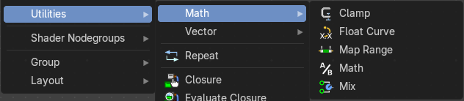
This menu contains nodes that deals with Math data.

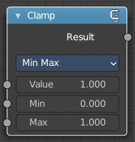
Clamp
The Clamp node clamps a value between a minimum and a maximum.

Inputs

Value
The input value to be clamped.

Min
The minimum value.

Max
The maximum value.

Properties

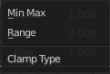
Clamp Type

Min Max
Clamp values using Min and Max values.

Range
Clamp values between Min and Max range.

Outputs

Result
The input value after clamping.

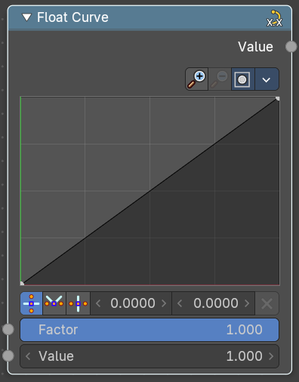
Float Curve
Generates a curve. This curve can then be used for profiles for example.

Inputs

Factor
The input factor.

Value
The input value.

Properties

Curve Widget

Navigation elements
The navigation elements at the top are described from left to right.

Zoom in and out
The two buttons with the magnifying glass at it zooms in and out in the curve window.

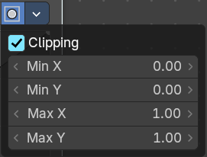
Clipping
Clipping options.

Tools
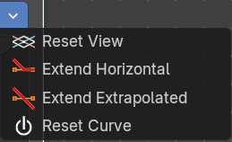
Tools is a menu where you can find some curve related tools.

Reset View
Resets the curve windows zoom.

Extend Horizontal
Extends the curve before the last point and after the last point horizontally.

Extend Extrapolation
Extends the curve before the last point and after the last point extrapolated.

Reset Curve
Resets the curve to the initial shape.

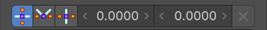
Vector Handle
Set handle type to Vector.

Auto Handle
Set handle type to Auto.

Auto Clamped Handle
Set handle type to Auto Clamped.

X / Y
The x and y position of the currently selected curve point.

Delete Points
Delete the currently selected curve point.

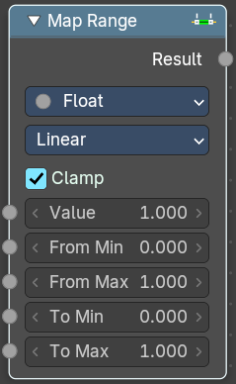
Map Range
The Map Range node remaps a value from a range to a target range.

Inputs

Value
The input value to be remapped.

From Min
The lower bound of the range to remap from.

From Max
The higher bound of the range to remap from.

To Min
The lower bound of the target range.

To Max
The higher bound of the target range.

Properties

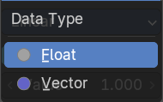
Data Type
The data type to calculate.

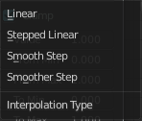
Interpolation Type

Linear
Linear interpolation between From Min and From Max values.

Stepped Linear
Stepped linear interpolation between From Min and From Max values.

Smooth Step
Smooth Hermite edge interpolation between From Min and From Max values.

Smoother Step
Smoother Hermite edge interpolation between From Min and From Max values.

Clamp
If enabled, the output is clamped to the target range.

Outputs

Result
The input value after remapping.

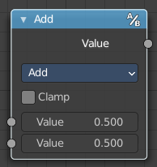
Math
The Math Node performs math operations.

Inputs

Value
First numerical value. The trigonometric functions accept values in radians.

Value
Second numerical value. This value is not used in functions that accept only one parameter like the trigonometric functions, Round and Absolute.

Properties

Operation
Here you can choose what mathematical operation to perform.
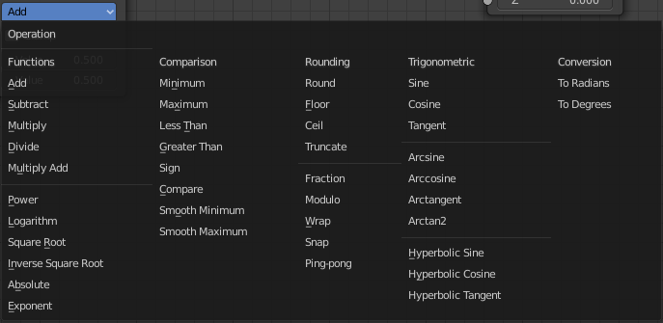

Clamp
Limits the output to the range (0 to 1). See clamp.

Outputs

Value
Numerical value output.

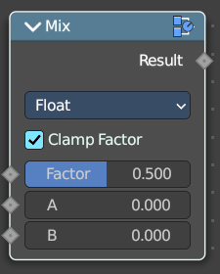
Mix
Allows to mix values and vectors in various ways. The node has three different modes. Float, Vector and Color

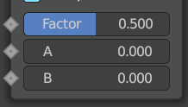
Input

Float

Factor
The mix factor.

A
Float value A input.

B
Float value B input.

Vector

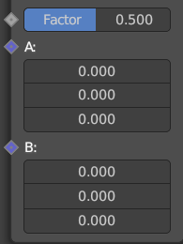
Factor mode Uniform

Factor
The mix factor.

A
Vector A input.

B
Vector B input.

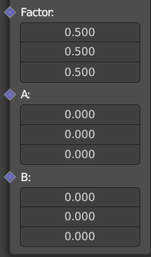
Factor mode Non Uniform

Factor
The vector mix factor.

A
Vector A input.

B
Vector B input.

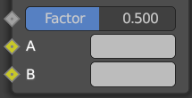
Color

Factor
The mix factor.

A
Color A input.

B
Color B input.

Properties

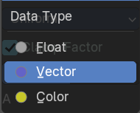
Data Type
Which mode to use.

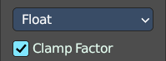
Float mode

Clamp Factor
Clamp the factor to 0-1 range.

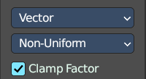
Vector mode

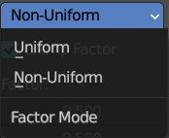
Factor mode
Uniform or non uniform factor.

Clamp Factor
Clamp the factor to 0-1 range.

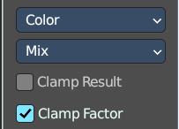
Color mode

Blending mode
What blending mode to use for the color.

Clamp Result
Clamp the result to 0-1 range.

Clamp Factor
Clamp the input factor to 0-1 range.

Output

Result
The output value or vector.

